
Blythe, John W
JB Creative
Contactless Payment guide

Blythe, John W
[Company name] [Company address]
Contactless Payment guide

Table of Contents
Contactless User Guide 2
A920 Debit/Credit Card Device General Information 2
A920 Overview – Front 3
A920 – Overview Back 4
Taking Payment with the A920 6
Make sales via card using contactless 6
Make sales via card without a card present 6
Make sales via card by inserting the card 7
Receipt Roll Installation 8
Record Keeping – Important 9
A920 FAQ 10

Contactless User Guide

A920 Debit/Credit Card Device General Information

- You are required to perform a basic visual check of your device at the start of each day looking for signs of tamper.

- Your device will have a security seal; this needs to be checked to ensure it has not been tampered with.

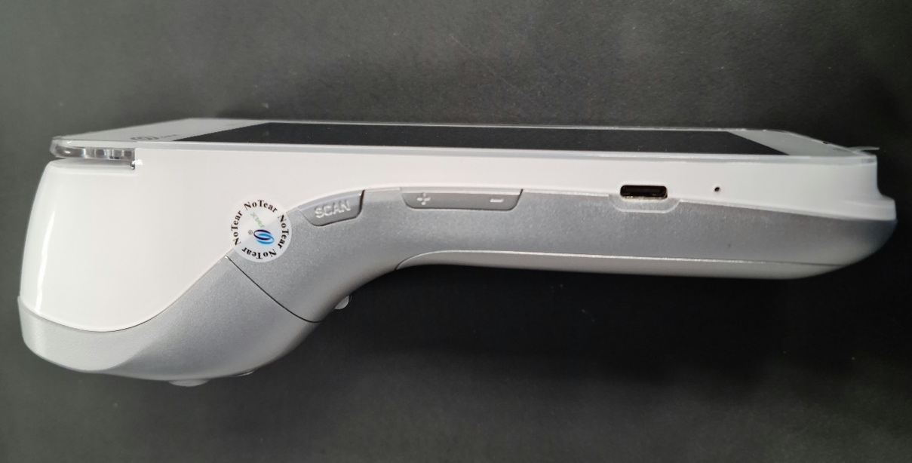

- If there are any untoward scratches, which lead you to believe someone may have tampered with the device, please raise your concerns with a member of the sales ledger team on ????.

- Your device(s) must be locked away securely at the end of each day, for example: in a safe, behind a secure shutter, in a locked cupboard.

- PCI checks will be performed by a member of finance staff on a quarterly basis. These will commence 3 months after your device(s) have been installed.

- If you have any issues with the A920 payment device please report this to ITSupport on ????.

A920 Overview – Front

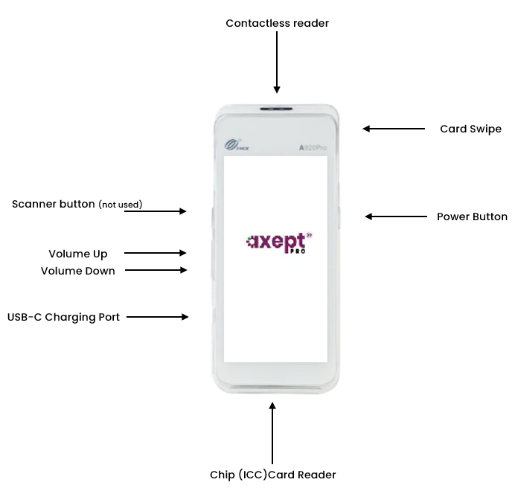

A920 – Overview Back

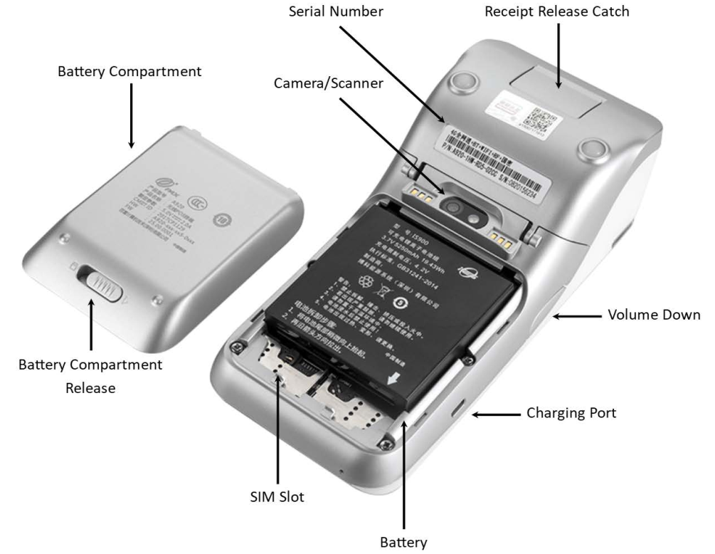

A920 Icon Overview

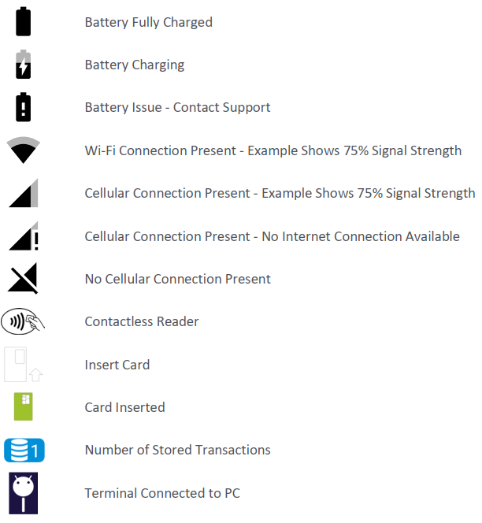

Taking Payment with the A920

Make sales via card using contactless
Description | Expected Result
Power up device by holding button on right hand side of device | Powers up
At home screen, tap Payments | Taken to log in page to enter user name and password
Insert user name and password and tap 'done' | Taken to main menu home page
Press 'sale' | Page displays 'sale and 'enter amount'
Enter relevant amount and tap 'done' | Taken to page with 'enter reference'
Enter a unique reference number for the transaction if desired, or press 'skip' | Taken to sale page with relevant amount on screen
Tap card at top of A920 | Screen displays 'processing' then 'card read OK, remove card' then 'processing transaction' then 'authorised'
Screen displays 'print cardholder copy?' | Press 'yes' or 'no' if receipt wanted
If 'yes' pressed, screen displayed 'printing - remove cardholder copy' | Receipt prints out top of A920
Press 'ok' on screen | 'Sale authorised' appears on screen and transaction receipt prints
Remove receipt and screen returns to main menu page | Screen is at main menu page.

Make sales via card without a card present
Description | Expected Result
Power up device by holding button on right hand side of device | Powers up
At home screen, tap Payments | Taken to log in page to enter user name and password
Insert user name and password and tap 'done' | Taken to main menu home page
Press 'card not present' | Press sale button (if logged in to process refunds)
Press 'card not present' | Taken to sales page (if not able to process refunds)
Tap 'phone order' at top of screen | Phone order option highlighted
Input all card details, house number and numbers from customers postcode | All fields inputted
Remove receipt and screen returns to main menu page | Screen is at main menu page.
Tap 'start transaction' if not completing customer billing info page | CNP page present transaction result page on screen detailing all the info captured
Tap 'Yes' | A920 prints cardholder copy receipt
Tap 'Ok' | Transaction receipt prints out and returns to home screen.
(If you) Tap 'no' | Transaction completes, transaction receipt prints out and returns to main menu.

Make sales via card by inserting the card
Description | Expected Result
Power up device by holding button on right hand side of device | Powers up
At home screen, tap Payments | Taken to log in page to enter user name and password
Insert user name and password and tap 'done' | Taken to main menu home page
Press 'sale' | Page displays 'sale and 'enter amount'
Enter relevant amount and tap 'done' | Taken to page with 'enter reference'
Enter a unique reference number for the transaction if desired, or press 'skip' | Taken to sale page with relevant amount on screen
Insert card into bottom of A920 | Screen displays 'processing' then 'card read OK, remove card' then 'processing transaction' then 'authorised'
Taken to screen to insert pin number | Insert pin and press green arrow
Screen displays 'print cardholder copy?' | Press 'yes' or 'no' if receipt wanted
If 'yes' pressed, screen displayed 'printing - remove cardholder copy' | Receipt prints out top of A920
Press 'ok' on screen | 'Sale authorised' appears on screen and transaction receipt prints
Receipt prints out and machine beeps to remove card | Remove card to stop beeping
Remove receipt and screen returns to main menu page | Screen is at main menu page.

Receipt Roll Installation
The A920 Pro terminal accepts standard 57mm wide x 40mm diameter Thermal Till Rolls.
Firstly, open the terminals receipt compartment by carefully lifting the release catch as shown.
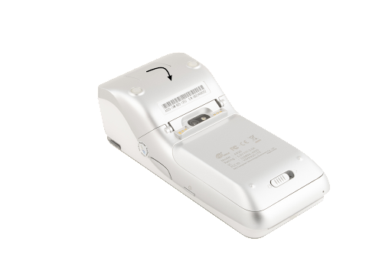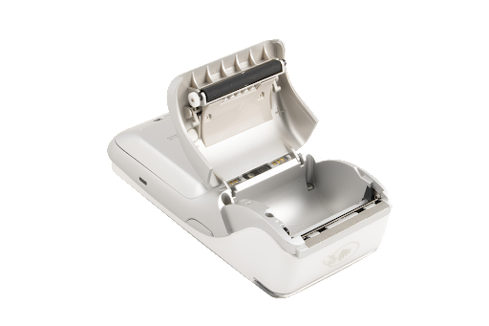
Once open, place the receipt roll provided into the open compartment with the receipt paper extending from underneath the roll leaving at least 1cm exposed and close the cover.
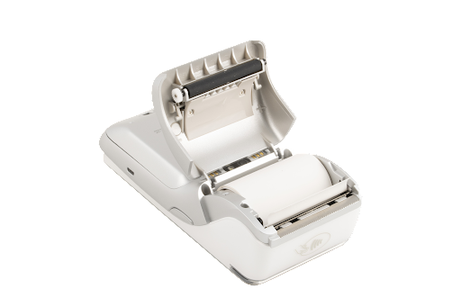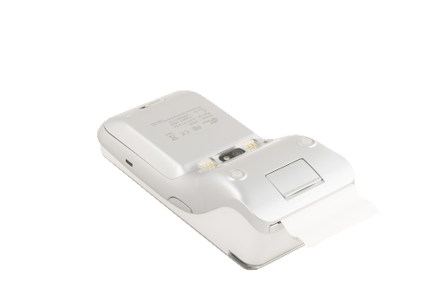
The receipt roll is then loaded and ready for printing.

Record Keeping – Important
If the terminals are printing a merchant receipt, there is a requirement for these to be retained for the current year and the previous six years.
They do not need to be submitted to finance just saved locally so please ensure you have a backup.

A920 FAQ

- What does the “reverse last transaction” do? Optomany do not support this feature, moving forward on the new user interface that has been introduced, this feature has now been removed.
- What does the “submit transactions” button do? This will submit any 'Stored transactions' on the terminal. The Optomany terminal will automatically submit for settlement within a few seconds of it being completed. This is why it not possible to do reverse last transaction and no need for batch uploads.
- Why doesn’t the A920 machine offer the ability to have a reference number on a refund, it’s only available when making a sale? When using the Optomany payment app, each transaction is given a reference number automatically. When selecting the refund option, there should be a small plus button at the top of screen with 'add reference'. This should allow the same thing as the reference screen when processing.

- What is the process for no chip and pin on card as can happen with international students? The Optomany terminals only support VISA, Mastercard and Amex. Amex needs to be setup separately. Providing the card is from one of these providers; swipe, contactless, chip and pin should all be fine. If a user with a chip card attempts to swipe, they will usually get prompted to insert the card instead.

- Do we need to do a T report? Is a T report a transaction report? Optomany provide access to their system which will allow users to pull any reports SHU would need for their estate. Optomany can set it up on your account so SHU are sent a daily report if required or alternatively a X or Z report can be run on the device and this will bring the totals for the day or the totals since the last Z report depending on which is run the device. Optomany recommend OCC reporting instead of terminal reporting as once the report on the terminal is produced the data is gone from the terminal but it is always there on OCC.

- If you tick the box saying 'Save my credentials' how long does this leave the person logged in for? The user will stay logged in until either they logout or if auto log off is enabled. This can be enabled in the app settings and can be set for between 1-60 minutes.

- If you make the screen size as big as it goes, you can’t get back to the settings to reduce the settings. How do you change it back? Optomany recommend that users change these settings. They say they’re forced to show the full display menu but Uniware recommend users only adjust brightness and sleep settings.

- What are the main things Optomany Cloud is used for? It is predominantly used for reporting and administration, including changing the log in details of each device. This is a function for our Finance colleagues to be able to use.

